TOWN OF PRINCESS ANNE
Legislative Agenda
Monday June 5, 2023, 6:30 PM.
LOCATION: Garland Hayward Youth Center
Princess Anne, Maryland, 21853
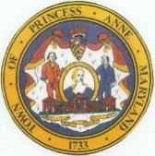
Joseph “Joey” Gardner
President
Orlondo “Dell” Taylor
Vice President
Lionel Frederick
Commissioner
Marshall Corbin
Commissioner
Shelley Johnson Paul Wilber
Commissioner Town Attorney

- Call to Order
- Pledge of Allegiance
- Moment of Silence
- Motion to Accept Agenda
- Motion to Accept May minutes
- June Citizens Merit Award: Nathanial Stacier
- First Reading of 2023-2024 Budget
- Department Head Reports
- Citizens Comments
- Commissioner Comments
- Work Session Agenda Items
- Adjournment

