TOWN OF PRINCESS ANNE
Legislative/Work Session Agenda
Monday May 15th, 2023, 6:00 PM.
LOCATION: Town Hall Conference Room
Princess Anne, Maryland, 21853
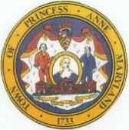
Joseph “Joey” Gardner
President
Orlondo “Dell” Taylor
Vice President
Lionel Frederick
Commissioner
Marshall Corbin Clayton Anderson
Commissioner Town Manager
Shelley Johnson Paul Wilber
Commissioner Town Attorney

Legislative Meeting

- Call to Order
- Pledge of Allegiance
- Moment of Silence
- Motion to Accept Agenda
- 2023-2024 Tax Rate

Work Session
- Call to Order
- Somerset Landing Drainage Update: Josh Taylor, DBF
- Planning and Zoning Commission Discussion
- Art Mural Applicants Discussion
- Trash Collection
- 2023-2024 Budget Discussion
- President and Commissioners Charter Changes

